Ideation Phase

Define the Problem Statements

Date | 28 January 2026
Team ID | LTVIP2026TMIDS66306
Project Name | Gemini historical artifact description
Maximum Marks | 3 marks

Customer Problem Statement Template:
I am a student, researcher, or museum curator trying to identify, analyze, and understand historical artifacts accurately, but there is no easy and fast way to get detailed and reliable artifact descriptions because artifacts require expert knowledge, historical context, and manual research, which makes me feel confused, slow in learning, and limited in accessing accurate historical information.

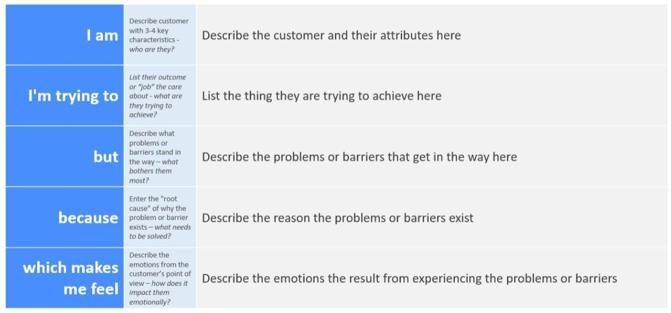
Example:

I am | I'm trying to | But | Because | Which makes me feel
a researcher | identify and understand historical artifacts accurately | traditional identification methods are slow and require expert knowledge | artifacts need detailed analysis, historical context. | confused, inefficient, and limited in accessing accurate historical
I am a Museum Curator | I’m trying to preserve and manage Gemini historical | But there is no secure and efficient digital system to store | Because traditional storage methods | Concerned about losing valuable historical artifacts and information

